Creating a Android/AOSP Build machine on Ubuntu 20.04
Reference link-https://back2basics.io/2020/05/creating-a-android-aosp-build-machine-on-ubuntu-20-04/

Introduction
In this guide I will be going through the process of setting up an Ubuntu 20.04 LTS machine for building custom Android ROMs. This will be done by setting up our machine, getting the Android Open Source Project's (AOSP) code from Google and actually building it. This guide will be aimed at building a Android 9 image for the Pixel 2 although this process should work on any Pixel device and possibly others. Given the size of the Android project, building will take a large amount of resources and time (several hours)

Requirements
- Fresh Ubuntu 20.04 Install
- Root privileges (or sudo)
- 300GB Disk space (or 180GB for source just for a single version of Android

Recommended Specs
I recommend doing this on a machine with the following specs
- 300+ GB SSD
- 12 CPU cores
- 16GB RAM
At the end of the day, the faster the machine, the faster the build. The slower the machine, the slower the build!

Setting up our machine

Updating
First thing we are going to want to do is do an apt update and upgrade to make sure we have the latest versions of all of our packages. This will be helpful for later when we do a big install.
sudo apt update
sudo apt upgrade

Installing required packages
Now we have the latest versions of all the packages we require, lets install everything we need to build Android!

sudo apt install openssh-server screen python git openjdk-8-jdk android-tools-adb bc bison \
build-essential curl flex g++-multilib gcc-multilib gnupg gperf imagemagick lib32ncurses-dev \
lib32readline-dev lib32z1-dev liblz4-tool libncurses5-dev libsdl1.2-dev libssl-dev \
libxml2 libxml2-utils lzop pngcrush rsync schedtool squashfs-tools xsltproc yasm zip zlib1g-dev \
libtinfo5 libncurses5
As you can see from the screenshot, this requires a lot of packages and may take a while to download.
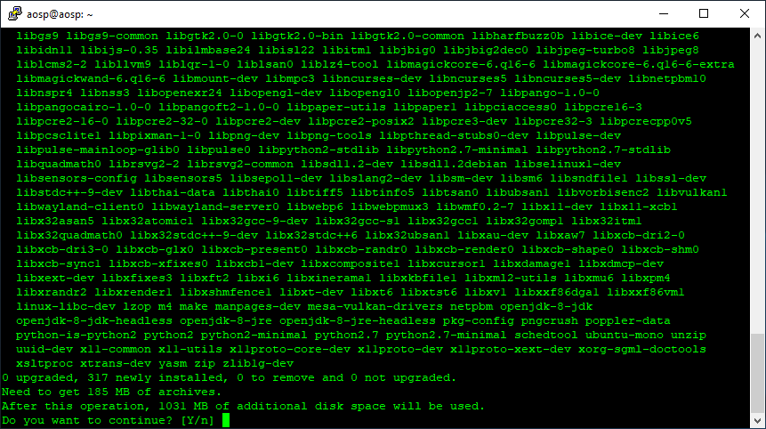

Downloading Sources

Setting up repo tool
In this next section, we are going to start the process of downloading all of the Android source code from Google. All of this code is stored across hundreds of git repositories. To handle downloading all of these, Google have released a tool called repo. We will need this to continue.
sudo wget 'https://storage.googleapis.com/git-repo-downloads/repo' -P /usr/local/sbin/
sudo chmod +x /usr/local/sbin/repo
You can test to make sure repo works by typing in repo. If you get the following, it should work
error: repo is not installed. Use "repo init" to install it here.
You will also need to setup git - These details will be used to identify you if you ever decide you want to contribute to AOSP.
git config – global user.email "you@example.com"
git config – global user.name "Your Name"

Finding the right branches for you
You can find the right build numbers / branch names / code names here. Its worth noting the correct tag for whatever device you want to build for. For example, I will be using the tag android-10.0.0_r5 to build for the Pixel device. This has the build id of QP1A.191005.007.A1

Download sources for branch
This could take a while so its worth creating a screen session so we can pickup where we left off later if we get disconnected.
screen -S aosp
Change to the directory you want the sources to be downloaded to - I have a seperate drive mounted to /aosp
cd /aosp
This command will then download all of the sources that are required for the branch mentioned after the b tag.
repo init -u https://android.googlesource.com/platform/manifest -b android-10.0.0_r5
If you are worried about space, you can use the --depth=1flag to the end of the command to only download source for your particular branch.
repo init -u https://android.googlesource.com/platform/manifest -b android-10.0.0_r5 – depth=1
When you do this, you should see something like this:
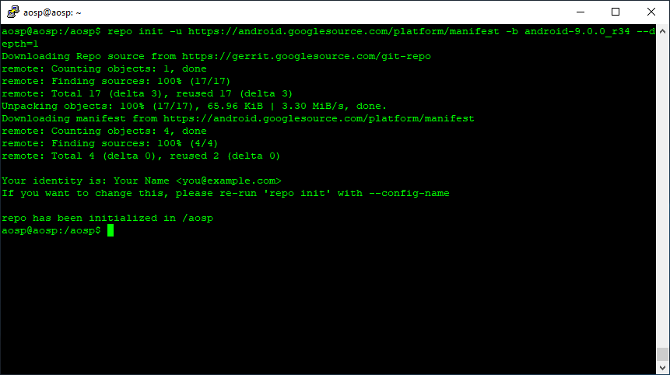
You can now sync to download all required files. The -j12 flag tells repo to use 12 cores when syncing. Change this to whatever is appropriate for your system.
repo sync -j12
This may take a while depending on the speed of your connection. Doing this on my system with a depth of 1 downloaded about 16GB and used 51GB disk space.

Proprietary Drivers
Before you are able to build, you will need to make sure that you have the device specific drivers downloaded if there are any. For Google Devices, this is pretty straight forward. You will need to go to Driver Binaries page and download the files for your device/codename. For me, this will be the links in the Pixel binaries for Android 10.0.0 r5 section. Make sure this is definitely for your device variant as there may be newer models which use different drivers. If you get the wrong ones, the device will not boot. Wget these files into the root of the AOSP directory

Driver Binaries-https://developers.google.com/android/drivers

android-10.0.0_r5

QP1A.191005.007.A1 | android-10.0.0_r5 | Android10 | Pixel 2 XL, Pixel 2, Pixel XL, Pixel | 2019-10-06

Pixel binaries for Android 10.0.0 (QP1A.191005.007.A1)

Hardware Component | Company | Download | SHA-256 Checksum
Vendor image | Google | Link | 229bb41ef1075cfae924f0f7cee854e3a2e218b12c24764114c3a5cd3f7071b7
GPS, Audio, Camera, Gestures, Graphics, DRM, Video, Sensors | Qualcomm | Link | 08e4febd2401ea5dc4df8ca94355388117e2c9a3f02069272d1a885f9ccb74d4
qcom-sailfish-qp1a.191005.007.a1-dca077a1.tgz
google_devices-sailfish-qp1a.191005.007.a1-e42a3654.tgz

wget https://dl.google.com/dl/android/aosp/google_devices-sailfish-qp1a.191005.007.a1-e42a3654.tgz
wget https://dl.google.com/dl/android/aosp/qcom-sailfish-qp1a.191005.007.a1-dca077a1.tgz
Once these are downloaded, you will need to extract them
tar -xzf qcom*
tar -xzf google_devices*
After this, you should notice there are two new files extract-google_devices-walleye.sh and extract-qcom-walleye.sh
You will need to execute each of these are then accept their terms and conditions.
./extract-google_devices-walleye.sh
and
./extract-qcom-walleye.sh
I recommend spamming the SPACE key until you are prompted with Type "I ACCEPT" if you agree to the terms of the license:. You can then type in I ACCEPT and return.
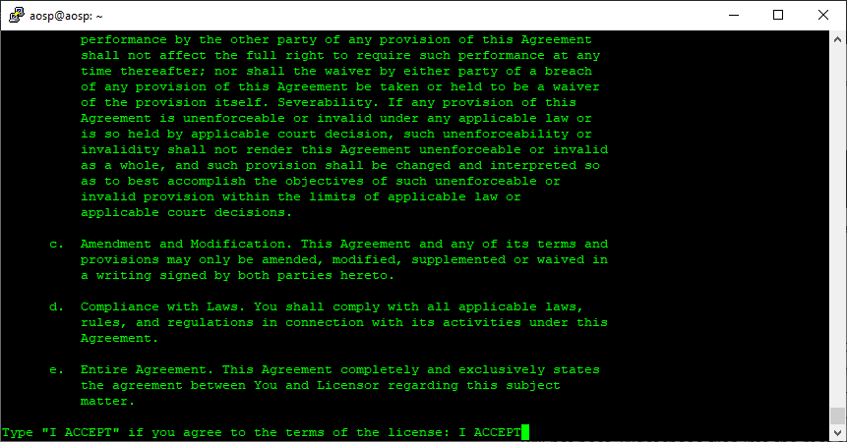

Building
Once you have all of the sources downloaded, you are almost ready to build. Before this however you will need to source the guild environment setup script. This will put all of the required build tools and functions into your PATH. You will need to do this every time you get a new terminal session. To be safe, just do it before every build.
source build/envsetup.sh
You can now use the lunch command (you will need to do this every time you want to build). This will load up a bunch of device profiles
lunch
The output for me is as follows:
You're building on Linux

Lunch menu... pick a combo:
1. aosp_arm-eng
2. aosp_arm64-eng
3. aosp_mips-eng
4. aosp_mips64-eng
5. aosp_x86-eng
6. aosp_x86_64-eng
7. aosp_car_arm-userdebug
8. aosp_car_arm64-userdebug
9. aosp_car_x86-userdebug
10. aosp_car_x86_64-userdebug
11. mini_emulator_arm64-userdebug
12. m_e_arm-userdebug
13. m_e_mips64-eng
14. m_e_mips-userdebug
15. mini_emulator_x86_64-userdebug
16. mini_emulator_x86-userdebug
17. uml-userdebug
18. aosp_crosshatch-userdebug
19. aosp_blueline-userdebug
20. aosp_cf_x86_auto-userdebug
21. aosp_cf_x86_phone-userdebug
22. aosp_cf_x86_tablet-userdebug
23. aosp_cf_x86_tablet_3g-userdebug
24. aosp_cf_x86_tv-userdebug
25. aosp_cf_x86_wear-userdebug
26. aosp_cf_x86_64_auto-userdebug
27. aosp_cf_x86_64_phone-userdebug
28. aosp_cf_x86_64_tablet-userdebug
29. aosp_cf_x86_64_tablet_3g-userdebug
30. aosp_cf_x86_64_tv-userdebug
31. aosp_cf_x86_64_wear-userdebug
32. cf_x86_auto-userdebug
33. cf_x86_phone-userdebug
34. cf_x86_tablet-userdebug
35. cf_x86_tablet_3g-userdebug
36. cf_x86_tv-userdebug
37. cf_x86_wear-userdebug
38. cf_x86_64_phone-userdebug
39. cf_x86_64_tablet-userdebug
40. cf_x86_64_tablet_3g-userdebug
41. cf_x86_64_tv-userdebug
42. cf_x86_64_wear-userdebug
43. aosp_marlin-userdebug
44. aosp_marlin_svelte-userdebug
45. aosp_sailfish-userdebug
46. aosp_walleye-userdebug
47. aosp_walleye_test-userdebug
48. aosp_taimen-userdebug
49. hikey-userdebug
50. hikey64_only-userdebug
51. hikey960-userdebug

Which would you like? [aosp_arm-eng]
From this list, select the most appropriate profile for your device. E.g. aosp_sailfish-userdebug for the pixel .
When building in the future, you can just type in
lunch aosp_sailfish-userdebug
The output of this should be something like this:
============================================
PLATFORM_VERSION_CODENAME=REL
PLATFORM_VERSION=9
TARGET_PRODUCT=aosp_walleye
TARGET_BUILD_VARIANT=userdebug
TARGET_BUILD_TYPE=release
TARGET_ARCH=arm64
TARGET_ARCH_VARIANT=armv8-a
TARGET_CPU_VARIANT=cortex-a73
TARGET_2ND_ARCH=arm
TARGET_2ND_ARCH_VARIANT=armv8-a
TARGET_2ND_CPU_VARIANT=cortex-a73
HOST_ARCH=x86_64
HOST_2ND_ARCH=x86
HOST_OS=linux
HOST_OS_EXTRA=Linux-5.3.0-42-generic-x86_64-Ubuntu-19.10
HOST_CROSS_OS=windows
HOST_CROSS_ARCH=x86
HOST_CROSS_2ND_ARCH=x86_64
HOST_BUILD_TYPE=release
BUILD_ID=PQ2A.190305.002
OUT_DIR=out
============================================
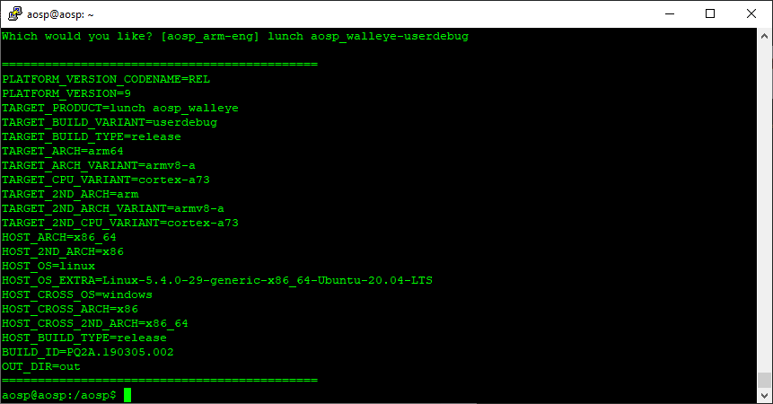

Now you are ready to build. This can be done using the make command.

make updatepackage -jN
Build everything with make. GNU make can handle parallel tasks with a -
jN argument, and it’s common to use a number of tasks N that’s between 1
and 2 times the number of hardware threads on the computer being used for
the build. For example, on a dual-E5520 machine (2 CPUs, 4 cores per CPU,
2 threads per core), the fastest builds are made with commands between make
-j16 and make -j32. In our project we can build the code by executing below
command
$ make updatepackage -jN
export LC ALL=C
You generally run a command with LC_ALL=C to avoid the user's settings to interfere with your script.
make -j12

Google play service integration in aosp

Why download GApps?
You need to download Gapps when you install a custom ROM on your Android phone, tablet, TV or watch. Most custom ROMs are built using the AOSP (Android Open Source Project) code. And since AOSP is completely independant of Google services, you need to install Google services and apps (GApps package) separately.
Some of the popular ROMs that require GApps are: CyanogenMod / LineageOS, ParanoidAndroid, ResurrectionRemix etc.
This is also particularly useful when you need to port Google Play services on Android phones that do not have them. But installing Google apps and services on such Andorid phones is not as easy as installing just one the Gapps package.

What is included in GApps package?

GApps package is a collection of services and applications that help you connect to Google with your account.Google Play Services,Google Play Framework etc. are some of the apps that are bundled along and make it possible for you to use your Google account with their apps.
Some of the Android Google apps are: Google Play Store app, Google Photos, YouTube, Google Maps, Google Search, Google Drive, Gmail, Google Play Music and Google Keep. To access Google Docs, Slides and Sheets, you may have to download and install them separately from the Google Play Store.

Reference link - open a link and follow the steps

https://github.com/opengapps/aosp_build

https://www.youtube.com/watch?v=rAGe3_yMe3w

open directory-android-10.0.0_r5 /aosp

step 1- sudo apt-get update
step 2- sudo apt-get upgrade
step 3 -sudo apt-get install git-lfs

Git LFS is an open-source project and is an extension to Git. The goal is to work more efficiently with large files and binary files into your repository.Git Large File Storage (LFS) replaces large files such as audio samples, videos, datasets, and graphics with text pointers inside Git, while storing the file
step 4- Add the build system, and the wanted sources to your manifest.

Find your manifest file (check inside $aosp/.repo/manifests/default.xml) and add the following towards the end:

<remote name="opengapps" fetch="https://github.com/opengapps/" />
<remote name="opengapps-gitlab" fetch="https://gitlab.opengapps.org/opengapps/" />

<project path="vendor/opengapps/build" name="aosp_build" revision="master" remote="opengapps" />

<project path="vendor/opengapps/sources/all" name="all" clone-depth="1" revision="master" remote="opengapps-gitlab" />

<!-- arm64 depends on arm -->
<project path="vendor/opengapps/sources/arm" name="arm" clone-depth="1" revision="master" remote="opengapps-gitlab" />
<project path="vendor/opengapps/sources/arm64" name="arm64" clone-depth="1" revision="master" remote="opengapps-gitlab" />

<project path="vendor/opengapps/sources/x86" name="x86" clone-depth="1" revision="master" remote="opengapps-gitlab" />
<project path="vendor/opengapps/sources/x86_64" name="x86_64" clone-depth="1" revision="master" remote="opengapps-gitlab" />

we are fetching opengapps from https://github.com/opengapps in this path aosp/vendor/opengapps and similarly fetching gitlab from https://gitlab.opengapps.org/opengapps/

Google Apps for Different Platforms
The following is a list of platforms supported by Google Apps and where they could run properly. They are listed as follows:
- ARM
- ARM64
- x86
- x86_64
You can read up more in detail about these platform types and what they offer in the article below. Just FYI, most of our recent phones are all based on the ARM64 architecture. So that is what you will most probably need.
ARM
ARM used to be the most popular 32-bit platform for Android phones. Almost every chipset and phone hardware before 2016 was powered by a 32-bit platform. Phones older than that period will need Gapps based on this platform. Do not try to run Gapps that were made for the 64-bit systems before that could crash your phone.
ARM64
ARM64 is the currently used, most popular platform. Almost all new Android phones and tablets are based on the 64-bit system. Phones moved on to this system in the late 2016 and the very early adopters include: Google Nexus 6P, Nexus 5X etc. Safe to say, every flagship phone since last year is based on 64-bit.
x86
Intel chipsets are very uncommon on Android phones. Only a handful of devices are based on the Intel x86 platform. One device that comes to mind is Asus Zenfone. We doubt you will hardly ever need Gapps for the x86 platform.
x86_64
Gapps for the x86_64 are more commonly used on Android emulators. All these emulators are optimized and based on Intel chipsets. And since all computers now support 64-bit systems, this should be your choice of platform when downloading Gapps for Android emulators. This is useful for development purposes or if you just want to run and install Google apps on your PC or Mac.

step 5- repo sync

repo sync updates working tree to the latest revision. That's, it synchronizes local project directories with the remote repositories specified in the manifest file.
repo sync run successfully then inside vendor opengapps folder is created.

step 6- Set the desired OpenGapps variant

In your device/google/marlin/product/ device-sailfish.mk file, in the beginning, add:
GAPPS_VARIANT := pico

https://www.xda-developers.com/open-gapps-android-10-roms/

We are selected VARIANT as a pico this is a popular choice by many if you are careful about what apps use your internal storage of the phone.pico size is low appoximately 113 mb and it’s bare minimum set of GApps that is required to run Google services on an Android device.
Pico includes Google Search app, Google Play Store etc.

step 7 - Include the opengapps-packages.mk file

The opengapps-packages.mk file will make the Android build system build the necessary PRODUCT_PACKAGES, and include the necessary PRODUCT_COPY_FILES.
In device/google/marlin/device-sailfish.mk file, towards the end, add:

$(call inherit-product, vendor/opengapps/build/opengapps-packages.mk)

How it works

When building in an AOSP tree, the build system processes the file device/manufacturer/product/device.mk very early, which means that the file vendor/opengapps/build/opengapps-packages.mk is also processed very early. This causes two special build "functions" (generic build rules) to be defined before any Android.mk files are read:

BUILD_GAPPS_PREBUILT_APK # - for apps
BUILD_GAPPS_PREBUILT_SHARED_LIBRARY # - for shared libraries

The definitions use the already existing AOSP build infrastructure for prebuilt APKs and SHARED_LIBRARYs, but remove a lot of the boilerplate.
The build rules take care of locating the correct APK/libraries in an architecture-independent way. The AOSP based build system already prioritizes SoC architecture. E.g. if it finds an apk in sources/arm64 and sources/arm, it will automatically prioritize sources/arm64.
The APK rule will also scan the APK for any libraries, and if it finds libraries it will get the AOSP build system to automatically extract them and place them at the expected place

Gapps Variants – Which one should you download?
Here is a list of the variants offered and the differences among them. From here you can decide the one you want to download and why.
There are seven different variants available. They are listed as below:
- pico
- nano
- micro
- mini
- full
- stock
- super
For more details on them and which you to go for, you can read all about them in the following paragraphs.
pico(113mb)
This is the bare minimum set of GApps that is required to run Google services on an Android device. It only comes with a small set of Google apps like the Google Search app, YouTube, Google Play Store etc. This is a popular choice by many if you are careful about what apps use your internal storage of the phone.
nano
nano is our favourite choice of GApps. It comes with the basic Google functionality and some more that is not available from the Google Play Store. It is slightly bigger in size than pico and gets the job done well. This is the package / variant we have covered below for you to download.
micro(196mb)
micro GApps package include everything from pico and nano packages. Plus, it also comes with a limited set of apps i.e. Gmail, Google Calendar, Google Assistant and some extra functionality as well.
mini
This set brings even more Google apps along with the basic functionality. You can expect most of the popular Google apps included as part of this package.
full(692mb)
If you own an OEM based phone and your custom ROM already includes the stock apps from the OEM’s platform, you should go with the full GApps package. Mainly because the full package will install all the recommended Google apps and will not replace the OEM-based stock apps.
stock
This is very similar to the full package, but this will replace any non-Google apps available. For example, if there is already a Calendar app available in the ROM, it will be replaced with the Google Calendar version from the Play Store.
super
If you are like me who wants every Google app installed on the phone, then this Super package is the way to go for. It comes with every Google app that has ever shipped with a phone. You can expect apps like Google Sheets, Slides or Docs also included as part of this package.

step 8-Build Android

source build/envsetup.sh
Once you have all of the sources downloaded, you are almost ready to build. Before this however you will need to source the guild environment setup script. This will put all of the required build tools and functions into your PATH.

After environment setup done,run following commands:
lunch
lunch 16
make updatepackage
FAILED:
build/make/core/tasks/vendor_module_check.mk:82: error: Error: Product "aosp_sailfish" cannot have overlay in vendor tree: vendor/opengapps/build/overlay/pico vendor/opengapps/build/overlay/assistant/28.
17:07:32 ckati failed with: exit status 1
refrence link -https://github.com/opengapps/aosp_build/issues/216
solution-
device/google/marlin/aosp_sailfish.mk file and aosp_marlin.mk
PRODUCT_RESTRICT_VENDOR_FILES := ture
make it false
PRODUCT_RESTRICT_VENDOR_FILES := false

make updatepackage
Unable to open 'out/target/product/sailfish/obj/APPS/Phonesky_intermediates/package.apk' for verification
Unable to open 'out/target/product/sailfish/obj/APPS/Phonesky_intermediates/package.apk.unaligned' as zip archive
mv: bad 'out/target/product/sailfish/obj/APPS/Phonesky_intermediates/package.apk.aligned': No such file or directory
08:58:28 ninja failed with: exit status 1
Reference link: https://github.com/opengapps/aosp_build/issues/229
solution - Running "git lfs fetch --all" inside "vendor/opengapps/sources/arm" seems to download the real apk files however:
git lfs fetch --all

make updatepackage
ERROR
Unable to open 'out/target/product/sailfish/obj/APPS/Turbo_intermediates/package.apk' for verification
Unable to open 'out/target/product/sailfish/obj/APPS/Turbo_intermediates/package.apk.unaligned' as zip archive
mv: bad 'out/target/product/sailfish/obj/APPS/Turbo_intermediates/package.apk.aligned': No such file or directory
09:25:35 ninja failed with: exit status 1
refrence link https://github.com/phhusson/treble_experimentations/issues/1252
solution-
repo forall -r '.*opengapps.*' -c 'git lfs fetch && git lfs checkout'

step 9-make updatepackage
Build everything with make. GNU make can handle parallel tasks with a -
jN argument, and it’s common to use a number of tasks N that’s between 1
and 2 times the number of hardware threads on the computer being used for
the build. For example, on a dual-E5520 machine (2 CPUs, 4 cores per CPU,
2 threads per core), the fastest builds are made with commands between make
-j16 and make -j32. In our project we can build the code by executing below
command
$ make updatepackage -jN
step 10-export LC ALL=C
You generally run a command with LC_ALL=C to avoid the user's settings to interfere with your script.
Step 11 - make -j12
step 12-Flashing
After successfully building you should be able to flash your Android ROM on to your device.Assuming that the Pixel is unlocked and booted into the bootloader and plugged into the machine you are building on, you should be good to go. First of all, set the following environment variable with this command:
fastboot -w update out/target/product/sailfish/aosp_sailfish-img-eng.cdac.zip

Package Comparison

Refrence link-https://github.com/opengapps/opengapps/wiki/Package-Comparison

Legend | Description
X | Installs application by default
O | Replaces the Stock/AOSP version of the application by default
+ | Only installed if Google Calendar is NOT installed
4.4 | Application is installed on Android 4.4 only
7.1 | Application is installed on Android 7.1 only
Application Name | gapps-config keyword | p  i  c  o | n  a  n  o | m  i  c  r  o | m  i  n  i | f  u  l  l | s  t  o  c  k | s  u  p  e  r
Google Play Services |  | X | X | X | X | X | X | X
Google Play Store |  | X | X | X | X | X | X | X
Google System Base |  | X | X | X | X | X | X | X
Google Calendar Sync | CalSync | X | X | + | + | + | + | +
Dialer Framework | DialerFramework | X | X | X | X | X | X | X
Google Text-to-Speech | GoogleTTS | X | X | X | X | X | O | O
Google Package Installer | PackageInstallerGoogle | O | O | O | O | O | O | O
Sounds | SoundPicker |  | X | X | X | X | X | X
Device Health Services | BatteryUsage |  | X | X | X | X | X | X
Google Markup | Markup |  | X | X | X | X | X | X
Google App (Search) | Search |  | X | X | X | X | X | X
Offline Speech Files | Speech |  | X | X | X | X | X | X
Google Digital Wellbeing | Wellbeing |  | X | X | X | X | X | X
Actions Services² | ActionsServices |  |  | X | X | X | X | X
Google Calendar¹ | CalendarGoogle |  |  | O | O | O | O | O
Google Exchange Services¹ | ExchangeGoogle |  |  | O | O | O | O | O
Gmail | Gmail |  |  | X | X | X | O | O
Google Now Launcher² | GoogleNow |  |  | 4.4 | 4.4 | 4.4 | 4.4 | 4.4
Pixel Icons | PixelIcons |  |  | 7.1 | 7.1 | 7.1 | 7.1 | 7.1
Pixel Launcher² | PixelLauncher |  |  | O | O | O | O | O
Google Wallpapers | Wallpapers |  |  | O | O | O | O | O
Google Calculator¹ | CalculatorGoogle |  |  |  | O | O | O | O
Carrier Services | CarrierServices |  |  |  | X | X | X | X
Google Clock¹ | ClockGoogle |  |  |  | O | O | O | O
Google Maps | Maps |  |  |  | X | X | X | X
Google Messages¹ | Messenger |  |  |  | O | O | O | O
Google Photos | Photos |  |  |  | X | X | O | O
Google Tags¹ | TagGoogle |  |  |  | O | O | O | O
YouTube | YouTube |  |  |  | X | X | X | X
Google Play Books | Books |  |  |  |  | X | X | X
Google Chrome⁴ | Chrome |  |  |  |  | X | O | O
Cloud Print | CloudPrint |  |  |  |  | X | X | X
Google Drive | Drive |  |  |  |  | X | X | X
Google Keep Notes | Keep |  |  |  |  | X | X | X
Google Play Movies & TV | Movies |  |  |  |  | X | X | X
Google Play Music | Music |  |  |  |  | X | X | X
Google News | Newsstand |  |  |  |  | X | X | X
Google Play Games | PlayGames |  |  |  |  | X | X | X
Google Accessibility Suite | TalkBack |  |  |  |  | X | X | X
Google Recorder | Recorder |  |  |  |  | X | X | X
Android Auto | AndroidAuto |  |  |  |  |  | X | X
Google Camera¹ | CameraGoogle |  |  |  |  |  | O | O
Google Contacts¹ | ContactsGoogle |  |  |  |  |  | O | O
Google Phone² | DialerGoogle |  |  |  |  |  | X | X
Google Duo | Duo |  |  |  |  |  | X | X
Google Pay | GooglePay |  |  |  |  |  | X | X
Google Keyboard¹ | KeyboardGoogle |  |  |  |  |  | O | O
Google Print Recommendation Service | PrintServiceGoogle |  |  |  |  |  | O | O
Google Smart Storage | StorageManagerGoogle |  |  |  |  |  | O | O
Google Translate | Translate |  |  |  |  |  | X | X
Google VR Services | VRService |  |  |  |  |  | X | X
Android System Webview¹⁴ | WebViewGoogle WebViewStub³ |  |  |  |  |  | O | O
Better Together | BetterTogether |  |  |  |  |  |  | X
Google Apps Device Policy | DMAgent |  |  |  |  |  |  | X
Google Docs | Docs |  |  |  |  |  |  | X
Google Earth | Earth |  |  |  |  |  |  | X
Google Fit | Fitness |  |  |  |  |  |  | X
Google Connectivity Services | GCS |  |  |  |  |  |  | X
Google Hangouts | Hangouts |  |  |  |  |  |  | X
Google Indic Keyboard | Indic |  |  |  |  |  |  | X
Google Japanese Input | Japanese |  |  |  |  |  |  | X
Google Korean Input | Korean |  |  |  |  |  |  | X
Google Pinyin Input | Pinyin |  |  |  |  |  |  | X
Project Fi² | ProjectFi |  |  |  |  |  |  | X
Google Sheets | Sheets |  |  |  |  |  |  | X
Google Slides | Slides |  |  |  |  |  |  | X
Google Street View | Street |  |  |  |  |  |  | X
Google Zhuyin Input | Zhuyin |  |  |  |  |  |  | X

Adding extra packages

You can add packages from versions higher then your set version. E.g. if you want to include Chrome, YouTube,Maps,Photos,Hangouts,Wallet,Wallpapers but you use
GAPPS_VARIANT := pico
In your device/google/marlin/device-sailfish.mkjust add,
for example:
GAPPS_PRODUCT_PACKAGES += GoogleCalendarSyncAdapter
GAPPS_PRODUCT_PACKAGES += GoogleDialer
GAPPS_PRODUCT_PACKAGES += GooglePackageInstaller
GAPPS_PRODUCT_PACKAGES += GoogleTTS
GAPPS_PRODUCT_PACKAGES += Gmail
GAPPS_PRODUCT_PACKAGES += Chrome
GAPPS_PRODUCT_PACKAGES += YouTube
GAPPS_PRODUCT_PACKAGES += Maps
GAPPS_PRODUCT_PACKAGES += Photos
GAPPS_PRODUCT_PACKAGES += Hangouts
GAPPS_PRODUCT_PACKAGES += Wallet
GAPPS_PRODUCT_PACKAGES += Wallpapers

This uses the module name. You can find the module name for a package by checking vendor/opengapps/build/modules/ and look at the LOCAL_MODULE name.
Refrence link:https://github.com/opengapps/aosp_build

make updatepackage

Out of space? Out of inodes? The tree size of /home/cdac/Documents/android_10_r5/Backup/pico_variant/android_10_with_gapps/aosp/out/soong/.temp/tmp4r9XBD is 2209185792 bytes (2106 MB), with reserved space of 0 bytes (0 MB).
The max image size for filesystem files is 2113941504 bytes (2016 MB), out of a total partition size of 2147483648 bytes (2048 MB).
09:55:24 ninja failed with: exit status

This error because of :The property is based on BOARD_SYSTEMIMAGE_PARTITION_SIZE in device/google/marlin/marlin/BoardConfig.mk,
for example:
BOARD_SYSTEMIMAGE_PARTITION_SIZE := 1006632960
If the resulting system.img is larger then this, then the Android build system will fail.You should use a smaller gapps package.
You could increase the BOARD_SYSTEMIMAGE_PARTITION_SIZE but then you need access to the bootloader, to change the partition table. I.e. it's not recommended :)

Reference link-https://github.com/opengapps/aosp_build/issues/13
Path:device/google/marlin/salfish/BoardConfig.mk,

BOARD_SYSTEMIMAGE_PARTITION_SIZE := 2147483648

BOARD_SYSTEMIMAGE_PARTITION_SIZE := 2209185792

Writing 'system_a' FAILED (remote: 'size too large')
fastboot: error: Command failed
https://github.com/phhusson/treble_experimentations/issues/1161

When we changed the variant pico to stock in existing file.
Path :device/google/marlin/sailfish-device.mk
GAPPS_VARIANT := pico
GAPPS_VARIANT := stock

Out of space? Out of inodes?
The tree size of /home/cdac/Desktop/android-10.0.0_r5/aosp/out/soong/.temp/tmpHYlhDG is 3359076352 bytes (3203 MB), with reserved space of 0 bytes (0 MB). The max image size for filesystem files is 2113941504 bytes (2016 MB), out of a total partition size of 2147483648 bytes (2048 MB)
. 11:17:20 ninja failed with: exit status 1

GAPPS_VARIANT:= micro

Out of space? Out of inodes? The tree size of /home/cdac/Documents/android_10_r5/Working/aosp/out/soong/.temp/tmpVZAU7q is 2343018496 bytes (2234 MB), with reserved space of 0 bytes (0 MB).
The max image size for filesystem files is 2113941504 bytes (2016 MB), out of a total partition size of 2147483648 bytes (2048 MB).
09:45:49 ninja failed with: exit status 1

GAPPS_VARIANT:= mini

Out of space? Out of inodes? The tree size of /home/cdac/Documents/android_10_r5/Working/aosp/out/soong/.temp/tmpVZAU7q is 2343018496 bytes (2234 MB), with reserved space of 0 bytes (0 MB).
The max image size for filesystem files is 2113941504 bytes (2016 MB), out of a total partition size of 2147483648 bytes (2048 MB).
09:45:49 ninja failed with: exit status 1

Path:device/google/marlin/sailfish/BoardConfig.mk,

BOARD_SYSTEMIMAGE_PARTITION_SIZE := 2147483648

BOARD_SYSTEMIMAGE_PARTITION_SIZE := 2343018496

change partition size but still same error.

Out of space? Out of inodes? The tree size of /home/cdac/Documents/android_10_r5/Working/aosp/out/soong/.temp/tmpCkge48 is 2343018496 bytes (2234 MB), with reserved space of 0 bytes (0 MB).
The max image size for filesystem files is 2113941504 bytes (2016 MB), out of a total partition size of 2147483648 bytes (2048 MB).
09:58:14 ninja failed with: exit status 1

